FULL STACK PROJECT REPORT

**On**

**MOVIE MANIA**

**Submitted by**

**Name of Student: ACHAL PALIWAL**

**Roll No: 181500032**

**Name of Student: PRASHANT AGRAWAL**

**Roll No: 181500486**

**Name of Student: SHASHANK GUPTA**

**Roll No: 181500653**

Department of Computer Engineering & Applications

**Institute of Engineering & Technology**



**GLA University**

**Mathura- 281406, INDIA**

**2020**

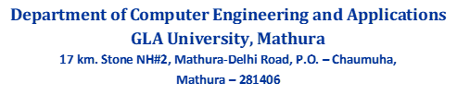



**Declaration**

We hereby declare that the work which is being presented in the fullstack Project “**Movie Mania”,** in partial fulfillment of the requirements for fullstack-Project LAB, is an authentic record of our own work carried under the supervision of **Mr. Pankaj Kapoor, Assistant Professor of CEA Department, GLA University, Mathura**.

<Signature of Candidate 1>

Name of Candidate 1: Prashant Agrawal

<Signature of Candidate 2>

Name of Candidate 2: Achal Paliwal

<Signature of Candidate3>

Name of Candidate 3: Shashank Gupta



**Department of Computer Engineering and Applications**

**GLA University, Mathura**

**17 km. Stone NH#2, Mathura-Delhi Road, P.O. – Chaumuha,**

**Mathura – 281406**

**CERTIFICATE**

This is to certify that the project entitled **“Movie Mania”** carried out in Full Stack Project – I Lab is a bonafide work done by **Achal Paliwal(181500032), Prashant Agrawal(181500486), Shashank Gupta (181500653)** and is submitted in partial fulfillment of the requirements for the award of the degree Bachelor of Technology (Computer Science & Engineering).

**Signature of Supervisor:**

**Name of Supervisor: Mr. Pankaj Kapoor**

**Date:**

**ACKNOWLEDGEMENT**

*It gives us a great sense of pleasure to present the report of the B. Tech Fullstack Project undertaken during B. Tech. Third Year. This project in itself is an acknowledgement to the inspiration, drive and technical assistance contributed to it by many individuals. This project would never have seen the light of the day without the help and guidance that we have received.*

*Our heartiest thanks to* ***Dr. (Prof). Anand Singh Jalal,*** *Head of Dept., Department of CEA for providing us with an encouraging platform to develop this project, which thus helped us in shaping our abilities towards a constructive goal.*

*We owe special debt of gratitude to* ***Mr. Pankaj Kapoor,*** *Assistant Professor Department of CEA, for his constant support and guidance throughout the course of our work. His sincerity, thoroughness and perseverance have been a constant source of inspiration for us. He has showered us with all his extensively experienced ideas and insightful comments at virtually all stages of the project & has also taught us about the latest industry-oriented technologies.*

*We also do not like to miss the opportunity to acknowledge the contribution of all faculty members of the department for their kind guidance and cooperation during the development of our project. Last but not the least, we acknowledge our friends for their contribution in the completion of the project.*

**ABSTRACT**

The project named “Movie Mania”, is a Web-based application created in HTML CSS Javascript bootstrap . The main purpose of this project is to provide user a platform to search the latest released movies and watch their trailers directly . Moviemania is a streaming service that offers a wide variety of award-winning movies, anime, documentaries, and more on thousands of internet-connected devices. You can watch as much as you want, whenever you want without a single commercial – all for free. You just have to visit the site and just check what type of movie you want to watch. the interface of this website is user friendly user can register and list his/her movie and by clicking the given link he or she can directly stream the movies or web-series.In this website there is lots of feature provided to a user as searching globaly, sorting the movie,rating and making list of watched movies .

**Table of Contents**

|  |  |  |
| --- | --- | --- |
| Declaration  Certificate  Acknowledgement  Abstract |  | II  III  IV  V |
| 1. Introduction |  | **1** |
|  |  |  |
| 1.1 Motivation  1.2 Overview  1.3 Objective |  | 1  1  1 |
|  |  |  |
| 2. Software Requirement Analysis |  | **2** |
|  |  |  |
| 2.1 Define Problem  2.2 Define Modules  2.3 Software Requirement  2.4 External Interface Requirement  2.5 Functional Requirement |  | 2  2  3  4  4 |
|  |  |  |
| 3. Software Design |  | **6** |
|  |  |  |
| 3.1 Data Flow Diagram  3.2 UML Diagram  3.3 Database Design |  | 6  7  8 |
|  |  |  |
| 4. Software Testing |  | **9** |
|  |  |  |
| 4.1 Testing of login session  4.2 Testing of main session |  | 9  12 |
|  |  |  |
| 5. Implementation and user Interface |  | **13** |
|  |  |  |
| 5.1 Implementation  5.2 User Interface |  | 13  15 |
|  |  |  |
| References/Bibliography  6.Appendices |  | **15** |
|  |  |  |

**Chapter 1. Introduction**

# Motivation

# The motivation behind this project is to provide movie viewers a good platform to watch movies or to know about upcoming and hit movies and series as there are many websites and software but they are not providing the information of hit movies all over the world.

* 1. **Overview**

Movie Mania is a streaming service that offers a wide variety of award-winning movies, anime, documentaries, and more on thousands of internet-connected devices. You can watch as much as you want, whenever you want without a single commercial – all for free.you just have to visit the site and just check what type of movie you want to watch.

**1.3 Objective**

Movie mania's objective is to provide best service among all movie’s website which are availabe at free of cost. User can search how many movies and web-series has released today and check the official trailer by just clicking on the given link.

**Chapter 2. Software Requirement Analysis**

**2.1 Problem Statement**

To provide such a website where user can search movies all over the world which is released today and watch them.

**2.2 Modules**

The project is based on several modules:

**2.2.1 Product perspective**

1. User Interface: The application will have a user-friendly and menu-based interface.Following pages will be provided:
2. A login page for entering the username, the password will be provided. Access to different Screens will be based on the user.
3. There is a page displaying movies and web series that are globally hit and there ratings.
4. There is a page for displaying information of particular film like production and all and the link of official trailer.
5. There is a page for displaying informatio of the team members.
6. There is a page for displaying information menu regarding what options the user will select .
7. There is a page for displaying search box where user can search any movie.
8. There is a menu where user can sort all those movie to easily extract them.
9. There is a page for displaying the results of searching movie that it is exists or not if exits then the page will display it.

**2.2.2 Product Functions**

The website will allow access only to authorized users with specific roles (Administrator- maintain the website details, User (Viewers), Movie Produsers .A summary of the major functions that the website will perform:

a. Provide facility to user to search movie globally and to watch that particular movie.

b. User Can see a list where all the movies and series that released today are listed it can be again sorted as per the requirement.

c. User Can login and Stream directly.

**2.2.2.1Administrators**

* Admin should be able to maintain the website and data.
* Update information about movies, production and companies rating etc.
* Can recommend the movies list to a user.

**2.2.2.2 User**

* Can find Movies and details
* Can direcly stream the movies and series on the platform.
* Can login to make a of watched movies list.

**2.2.2.3 Production Companies**

* Can update their profile
* Can check and update the details of the movies and series.

**2.2.3 User Characteristics**

No Prior Knowledge is Required but some key tips**-**

**a.** **Educational level:** Users should be comfortable with the English language.

**b**. **Experience:** Users should have prior information regarding the website and sreaming servises.

**c**. **Skills:** Users should have basic knowledge and should be comfortable using general purpose applications on computers.

**2.2.4 General Constraints**

* The time allotted for this project will be limited to the end of this semester.
* It can be happened that some information could not be correct because it is providing by other cells
* Programming is done by HTML,JAVASCRIPT,CSS,BOOTSTRAP.

# 2.3 Specific Requirements

This specific requirements describe the specific constraints impost on the requirements, enables the designer to design with full user satisfaction.

* Processor-i3
* Hard Disk-5GB
* Memory- 2 GB RAM
* Browser Internet Explorer/Chrome/Firefox

**2.4 External Interface Requirement**

**2.4.1 User Interfaces**

* **Home Screen-**Various fields available on this screen will be:
* Menu
* Movies Poster
* Search Options
* Team Information
* **Admin Login-**Fields available on this screen are:
* Login Name
* Password
* **Searching Movie -**Various Fields are:
* Movie Name
* Sort them
* Correct Movie
* **Movies List Screen-**Various Fields are:
* Movies Information
* Rating

**2.4.2 Hardware Interfaces**

* Screen resolution of at least 800X600 is required for proper and complete viewing of screens. Higher resolution will be accepted.

**2.4.3 Software Interfaces**

* Any windows/linux/mac operating system.
* Youtube links
* Visual Studio for developing code

### 

**2.4.4 Functional requirements**

**Criticality Scale: Low (1)-Medium (2)-High (3)**

1. **Low:** Items that can be eliminated should the need arise, without adversely affecting the product. These items are not urgent and not as important to the final product.
2. **Medium:**  items that are desired by the users of the system, but that may be postponed until the future release. These items are not urgent but important parts of the final product.
3. **High:** Items that are mission critical and without which the system cannot function in a manner that is satisfactory to the user. These items are urgently needed and important to the success of the final product.

**Chapter 3. Software Design**

**3.1 Data Flow Diagram**

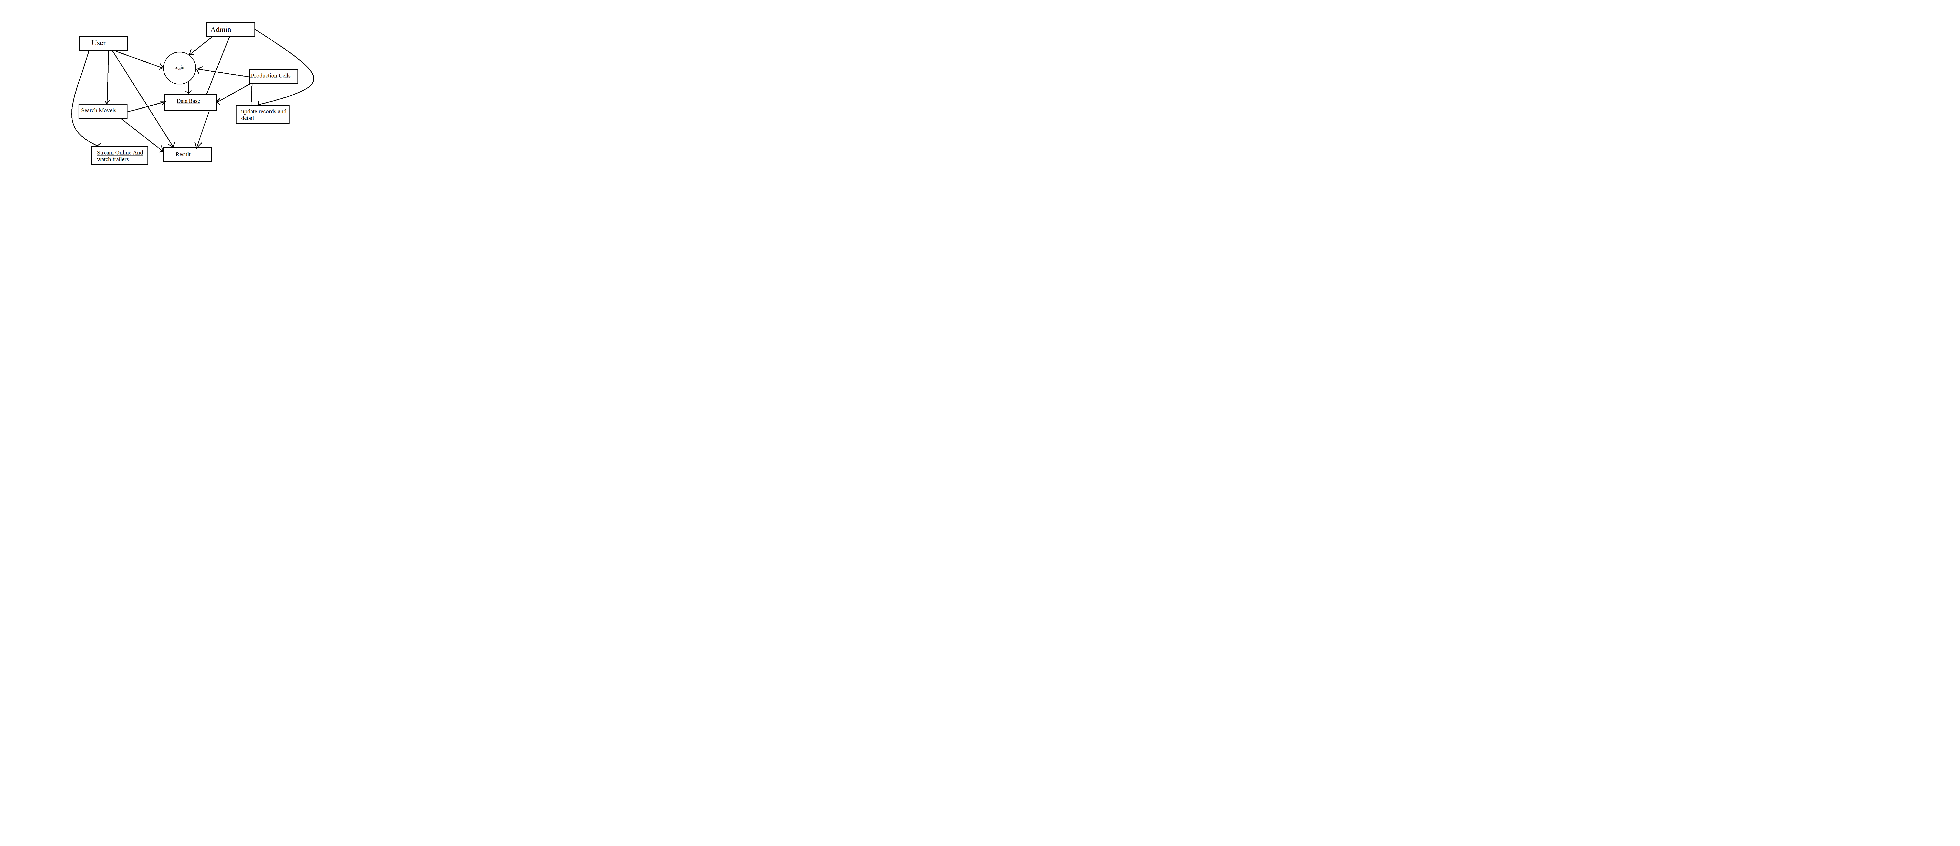

**Fig-1**

**3.2 UML Diagrams**

* + 1. **Use case Diagram**

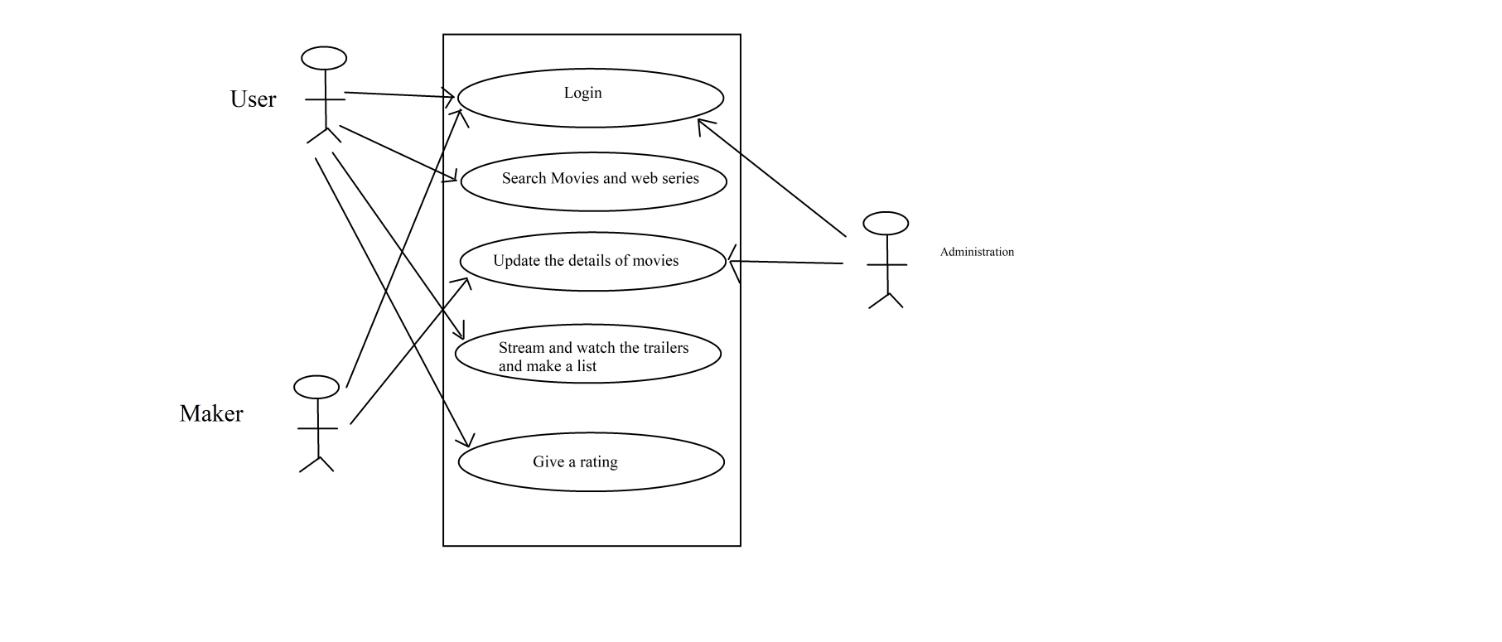

**Fig-2**

**3.2.2 Sequence Diagram**

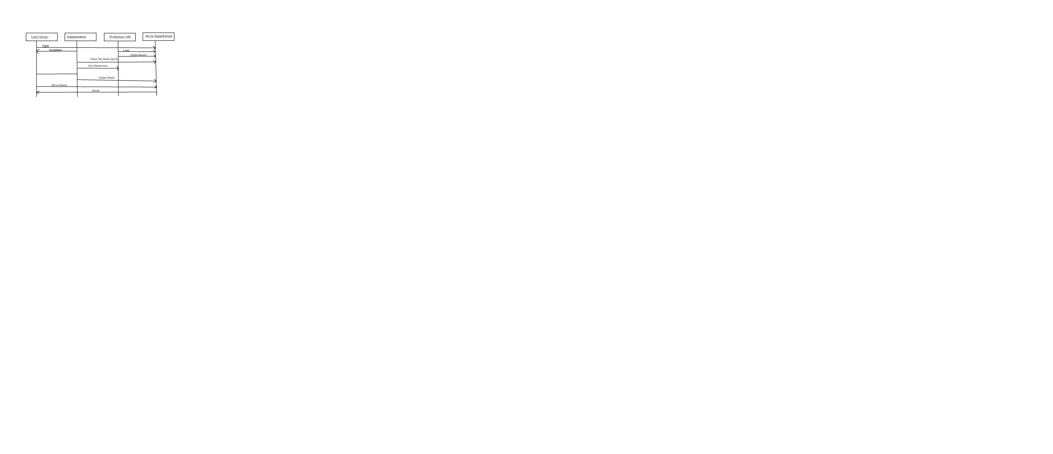

**Fig-3**

**3.3 Tables**

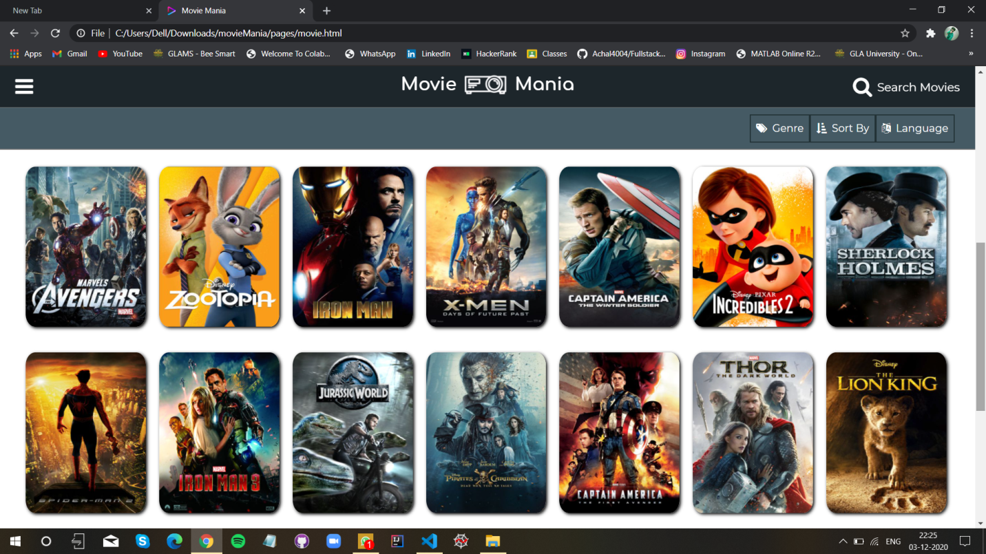

**Table No.-1**

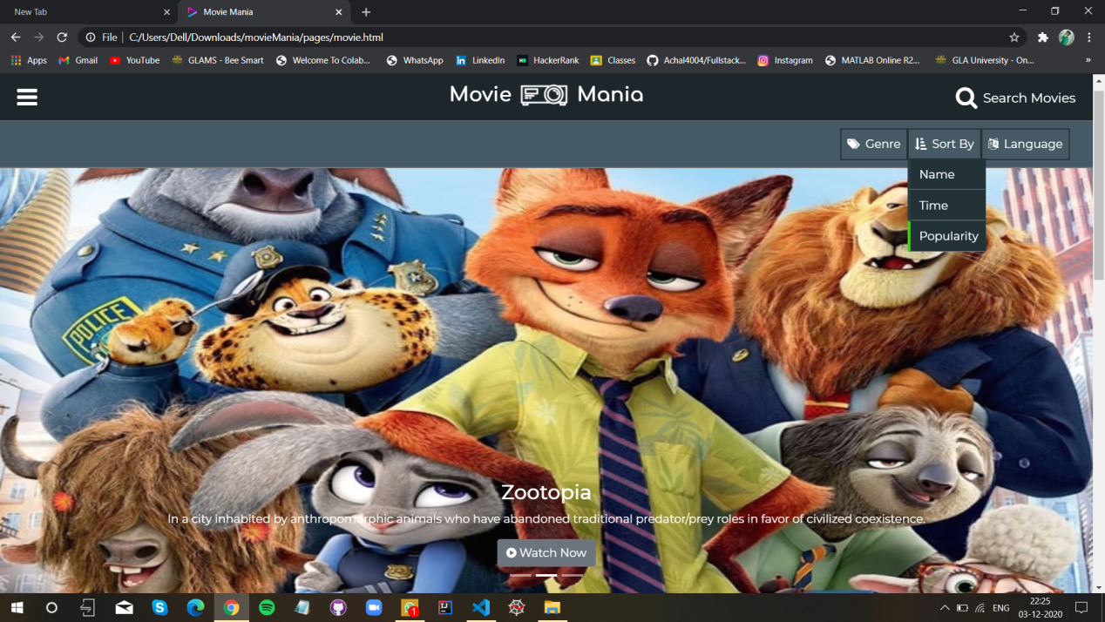

**Table No.-2**

**Chapter 4. Software Testing**

Software testing is an investigation conducted to provide stakeholders with information about the quality of the software product or service under testing. Software testing is a process of executing a program or application with intent of finding the software bugs. It can also be stated as the process of validating and verifying that a software program or application.

Various test cases are as follows:

**4.1 Testing of login session:**

|  |  |  |  |  |  |
| --- | --- | --- | --- | --- | --- |
| **Sr. No** | **Test Cases** | **Feature** | **Description** | **Steps to Execute** | **Test Data/Input** |
| **1.** | **TC-1** | **User Interface** | **Check all the test boxes ,radio buttons ,buttons etc.** | **1.Click on Radio buttons ,buttons and dropdown list** |  |
| **2.** | **TC-2** | **Required**  **fields** | **Check the required fields by not filling any data** | **1.Do not enter any value in the fields**  **2.Click on Signup button** | **NIL** |
| **3.** | **TC-3** | **Required**  **fields** | **Check required**  **fields by filling the data** | **1.Enter the valid values in required fields**  **2.Click on Signup button** | **NIL** |

Table No.-1

**4.2 Testing of main session:**

|  |  |  |  |  |  |  |  |  |
| --- | --- | --- | --- | --- | --- | --- | --- | --- |
| **Test**  **ID** | **Testing Method** | **Page** | **Purpose** | **Input** | **Expected**  **Output** | **Actual**  **Output** | | **Result** |
| **T1** | **Equivalence**  **Class Testing** | **Registration**  **Page** | **To check name** | **A-Z and**  **a-z** | **Error**  **message** | **Error**  **message** | **Pass** | |
| **T2** | **Equivalence**  **Class Testing** | **Registration**  **Page** | **To check name** | **1-9 or @,$, etc.** | **Error**  **message** | **No Error**  **message** | | **Fail** |
| **T3** | **Equivalence**  **Class Testing** | **Registration**  **Page** | **To check**  **Password** | **10 digit** | **Error**  **message** | **Error**  **message** | | **Pass** |
| **T4** | **Equivalence**  **Class Testing** | **Registration**  **Page** | **To check Password** | **11 digit** | **No Error**  **message** | **No Error**  **message** | | **Fail** |
| **T5** | **Equivalence**  **Class Testing** | **Movie Page** | **To check**  **Movie name** | **A-Z or**  **a-z** | **Error**  **message** | **Error**  **message** | | **Pass** |
| **T6** | **Equivalence**  **Class Testing** | **Movie Search Page** | **To check**  **Name** | **A-z or**  **a-z** | **Error**  **message** | **Error**  **message** | | **Pass** |
| **T7** | **Equivalence**  **Class Testing** | **Registration**  **Page** | **To check** | **0-9** | **Error**  **message** | **Error**  **Message** | | **Pass** |
| **T8** | **Equivalence**  **Class Testing** | **Search Page** | **To check**  **Rating** | **0-9** | **Error**  **Message** | **Error**  **message** | | **Pass** |
| **T9** | **Equivalence**  **Class Testing** | **Registration**  **Page** | **To check**  **Email** | **a-z+0-9+@+a-z+.+a-z** | **Error**  **message** | **Error**  **message** | | **Pass** |
| **T10** | **Equivalence**  **Class Testing** | **Registration**  **Page** | **To check name** | **A-Z or**  **a-z** | **Error**  **message** | **Error**  **message** | | **Pass** |
| **T11** | **Equivalence**  **Class Testing** | **Login**  **Page** | **To check**  **Username** | **a-z+0-9+@+a-z+.+a-z** | **Error**  **message** | **Error**  **message** | | **Pass** |
| **T12** | **Equivalence**  **Class Testing** | **Login page** | **To check** | **0-9** | **Error**  **message** | **Error**  **message** | | **Pass** |

Table No.-2

**Chapter 5 Implementation and User Interface**

**This is the Home page of the project which shows a menu bar showing various manubar showing various option for the Users**

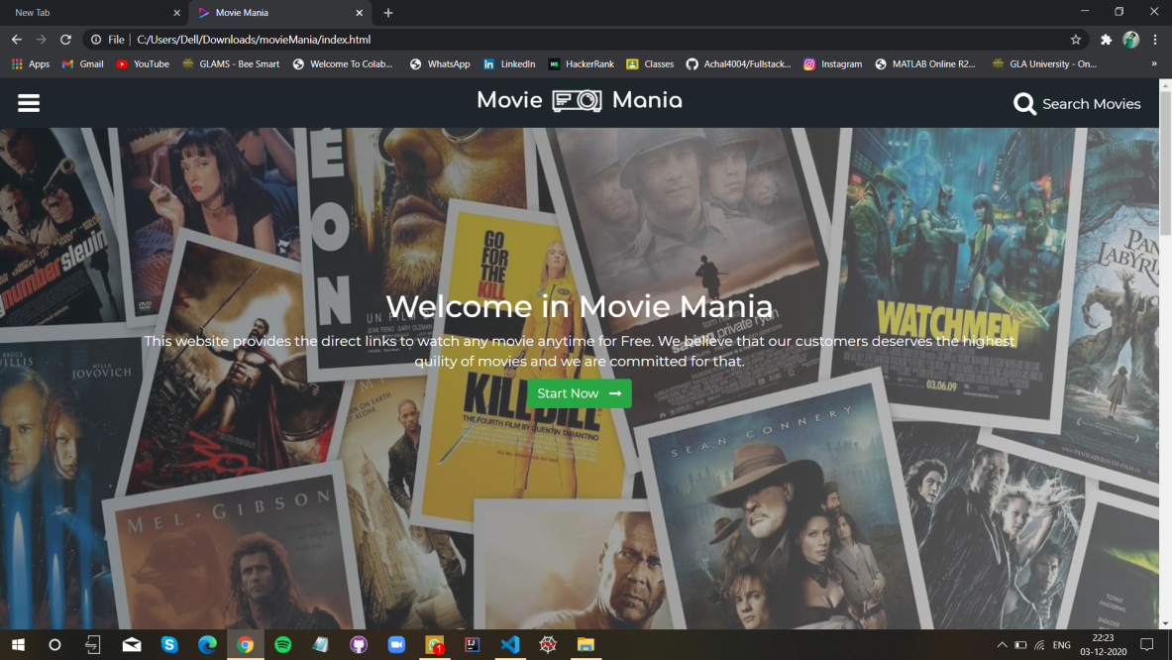

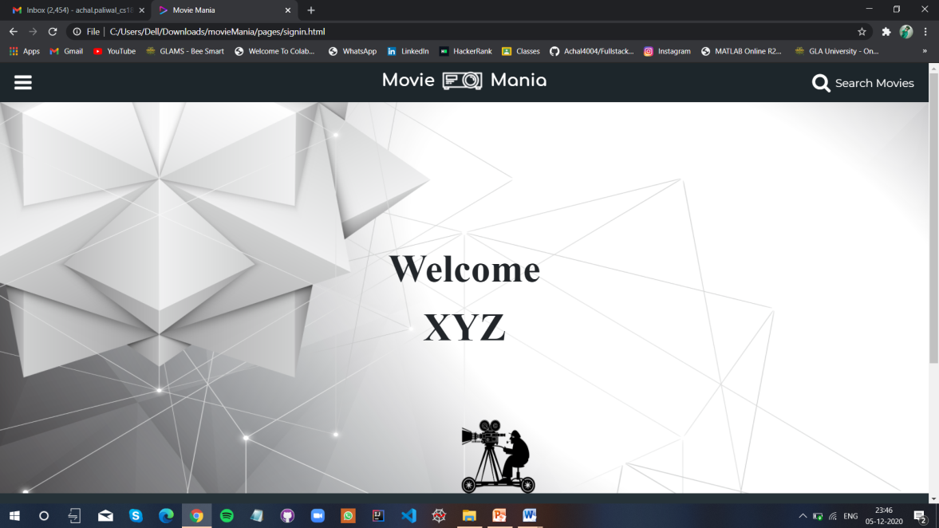 Fig-1

Fig-2

**5.2 - Login Page**

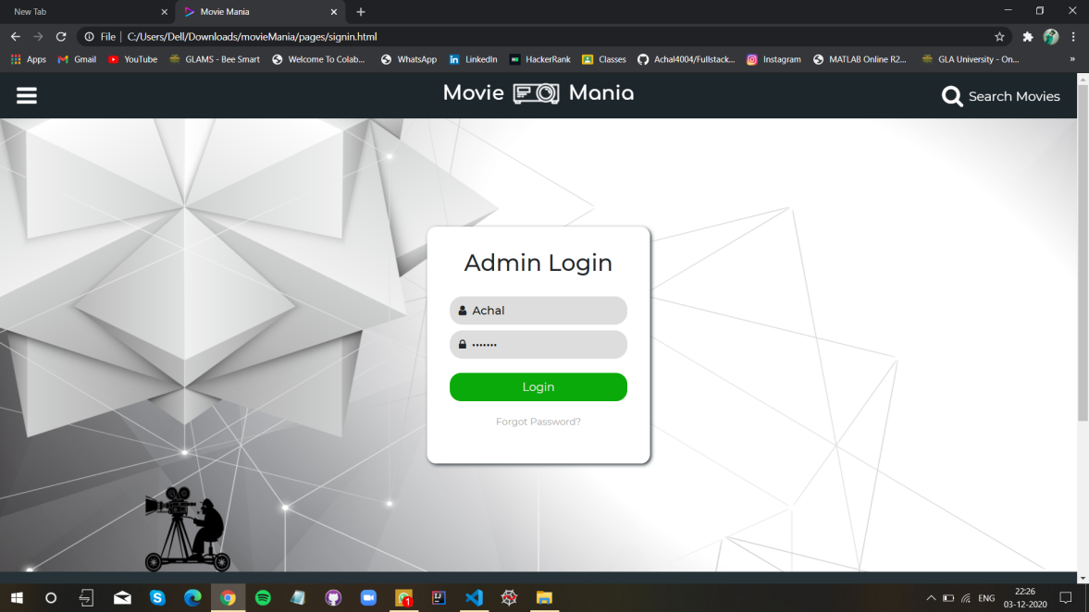

**Fig-3**

* 1. **Dashboard Pages-**

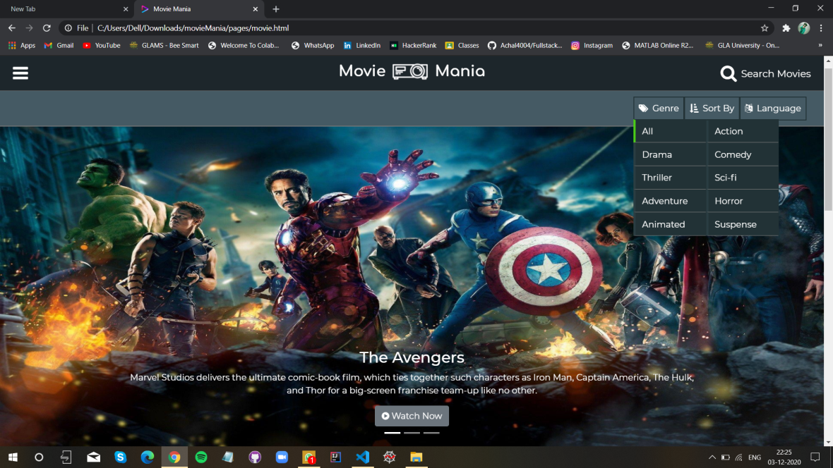

**Fig -4**

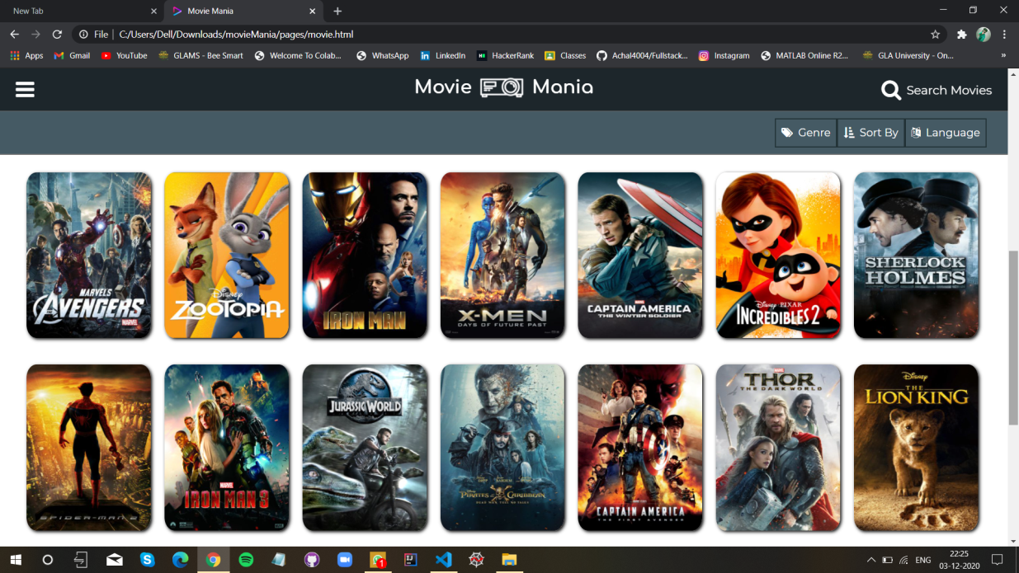

**Fig -5**

**Chapter 6 Appendices**

**Coding of index.html:**

<!DOCTYPE html>

<html lang="en">

<head>

    <meta charset="UTF-8">

    <meta name="viewport" content="width=device-width, initial-scale=1.0">

    <!-- cdn google font -->

    <link href="https://fonts.googleapis.com/css2?family=Montserrat:wght@400;500;700&display=swap" rel="stylesheet">

    <link href="https://fonts.googleapis.com/css2?family=Comfortaa:wght@700&display=swap" rel="stylesheet">

    <!-- cdn font-awesome -->

    <link rel="stylesheet" href="https://cdnjs.cloudflare.com/ajax/libs/font-awesome/4.7.0/css/font-awesome.min.css">

    <!-- cdn bootstrap -->

    <link rel="stylesheet" href="https://maxcdn.bootstrapcdn.com/bootstrap/4.0.0/css/bootstrap.min.css" integrity="sha384-Gn5384xqQ1aoWXA+058RXPxPg6fy4IWvTNh0E263XmFcJlSAwiGgFAW/dAiS6JXm" crossorigin="anonymous">

    <!-- custom stylesheet -->

    <link rel="stylesheet" href="./css/header.css">

    <link rel="stylesheet" href="./css/footer.css">

    <link rel="shortcut icon" href="./images/brand-logo-favicon.ico" type="image/x-icon">

    <link rel="stylesheet" href="./css/index.css">

    <title>Movie Mania</title>

</head>

<body>

    <nav class="header">

        <i class="fa fa-bars bars" onclick=menu()></i>

        <h3 class="brand-name">Movie</h3>

        <img class="brand-logo" src="./images/brand_img.png" alt="brand-logo">

        <h3 class="brand-name">Mania</h3>

        <a href="pages/search.html"><i class="fa fa-search search"><span>Search Movies</span></i></a>

        <ul class="links">

            <li><a href="#" ><i class="fa fa-home"></i>Home</a></li>

            <hr noshade="">

            <li><a href="pages/movie.html"><i class="fa fa-film"></i>Movies</a></li>

            <hr noshade="">

            <li><a href="#"><i class="fa fa-rss"></i>Blog</a></li>

            <hr noshade="">

            <hr noshade="">

            <li><a href="pages/signin.html"><i class="fa fa-sign-in"></i>Admin</a></li>

        </ul>

    </nav>

    <script src="javaScript/header.js"></script>

    <main>

        <!-- banner section -->

        <div class="banner">

            <img src="./images/banner.jpg" alt="banner">

            <div class="heading-1">

                <h1>Welcome in Movie Mania</h1>

                <p>This website provides the direct links to watch any movie anytime for Free. We believe that our customers deserves the highest quility of movies and we are committed for that.</p>

                <a href="./pages/movie.html" class='btn btn-success btn-large'>Start Now <i class="fa fa-long-arrow-right"></i></a>

            </div>

        </div>

        <!--Our feature section-->

        <div class="features">

            <h2>Our Features</h2>

            <ul class="feature-list">

                <li>

                    <i class="fa fa-star fa-2x"></i>

                    <h5>Awesome interface</h5>

                    <p>This website provides better user interface for fast and efficient experience.</p>

                </li>

                <li>

                    <i class="fa fa-database fa-2x"></i>

                    <h5>Large Collection</h5>

                    <p>1000+ collection of different types of  movies and web series.</p>

                </li>

                <li>

                    <i class="fa fa-rupee fa-2x"></i>

                    <h5>Free</h5>

                    <p>This website provides the direct links to watch any movie for Free.</p>

                </li>

            </ul>

        </div>

        <!--team section-->

        <div class="team">

            <h2>Our Creative Team</h2>

            <div class="team-members">

                <div class="member">

                    <img src="./images/team/member-1.jpg" alt="member-1">

                    <div class="about-member">

                        <h5>Shashank Gupta</h5>

                        <p>Team member</p>

                        <p>A self-motivated IT professional with huge knowledge and proficiency in JavaScript, HTML, CSS, and mobile responsive web development.</p>

                        <div class="social">

                            <a href="#"><i class="fa fa-twitter"></i></a>

                            <a href="#"><i class="fa fa-linkedin"></i></a>

                            <a href="#"><i class="fa fa-instagram"></i></a>

                        </div>

                    </div>

                </div>

                <div class="member">

                    <img src="./images/team/member-2.jpg" alt="member-2">

                    <div class="about-member">

                        <h5>Prashant Agrawal</h5>

                        <p>Team member</p>

                        <p>A self-motivated IT professional with huge knowledge and proficiency in JavaScript, HTML, CSS, and mobile responsive web development.</p>

                        <div class="social">

                            <a href="#"><i class="fa fa-twitter"></i></a>

                            <a href="#"><i class="fa fa-linkedin"></i></a>

                            <a href="#"><i class="fa fa-instagram"></i></a>

                        </div>

                    </div>

                </div>

                <div class="member">

                    <img src="./images/team/member-3.jpg" alt="member-3">

                    <div class="about-member">

                        <h5>Achal Paliwal</h5>

                        <p>Team member</p>

                        <p>A self-motivated IT professional with huge knowledge and proficiency in JavaScript, HTML, CSS, and mobile responsive web development.</p>

                        <div class="social">

                            <a href="#"><i class="fa fa-twitter"></i></a>

                            <a href="#"><i class="fa fa-linkedin"></i></a>

                            <a href="#"><i class="fa fa-instagram"></i></a>

                        </div>

                    </div>

                </div>

            </div>

            <p><a href="#" class="btn btn-large btn-outline-secondary">Learn More</a></p>

        </div>

        <!--video tutorial section-->

        <div class="video-tutorial-section">

            <h2>How to Watch Movies</h2>

            <div  class="video-tutorial">

                <div class="video">

                    <iframe  src="https://www.youtube-nocookie.com/embed/0cj71zkW-88" frameborder="0" allow="accelerometer; encrypted-media; gyroscope;" sandbox="allow-scripts allow-same-origin"></iframe>

                </div>

                <div class="about-video">

                    <h4>Video Tutorial</h4>

                    <p>This video tutorial guide how to use this website in more efficient manner. This video may also assist you in finding the solutions of your queries regarding the website. If your query will not be solved than you can contact our support team though e-mail.

                    </p>

                </div>

            </div>

        </div>

    </main>

    <footer>

        <div class="top">

            <div class="left-side">

                <ul class="contact">

                    <li><a href="#"><i class="fa fa-map-marker"></i>SCO-75, Chandigarh, India</a></li>

                    <li><a href="#"><i class="fa fa-phone"></i>+919797979733</a></li>

                    <li><a href="#"><i class="fa fa-envelope"></i>support@moviemania.com</a></li>

                </ul>

            </div>

            <div class="right-side">

                <div class="about">

                    <h4>About the website</h4>

                    <p>This website provides the direct links to watch any movie anytime for Free. We believe that our customers deserves the highest quility of movies and we are committed for that.</p>

                </div>

                <div class="social-container">

                    <ul class="social">

                        <li><a href="#"><i class="fa fa-facebook"></i></a></li>

                        <li><a href="#"><i class="fa fa-twitter"></i></a></li>

                        <li><a href="#"><i class="fa fa-linkedin"></i></a></li>

                        <li><a href="#"><i class="fa fa-google-plus"></i></a></li>

                    </ul>

                </div>

            </div>

        </div>

        <div class="bottom">

            <p><a href="#">&copy 2020 Copyright: Moviemania.com</a></p>

        </div>

    </footer>

    <!-- bootstrap js strat -->

    <script src="https://code.jquery.com/jquery-3.2.1.slim.min.js" integrity="sha384-KJ3o2DKtIkvYIK3UENzmM7KCkRr/rE9/Qpg6aAZGJwFDMVNA/GpGFF93hXpG5KkN" crossorigin="anonymous"></script>

    <script src="https://cdnjs.cloudflare.com/ajax/libs/popper.js/1.12.9/umd/popper.min.js" integrity="sha384-ApNbgh9B+Y1QKtv3Rn7W3mgPxhU9K/ScQsAP7hUibX39j7fakFPskvXusvfa0b4Q" crossorigin="anonymous"></script>

    <script src="https://maxcdn.bootstrapcdn.com/bootstrap/4.0.0/js/bootstrap.min.js" integrity="sha384-JZR6Spejh4U02d8jOt6vLEHfe/JQGiRRSQQxSfFWpi1MquVdAyjUar5+76PVCmYl" crossorigin="anonymous"></script>

    <!--bootstrap js end-->

</body>

</html>

**Movie Detail Page:**

<!DOCTYPE html>

<html lang="en">

<head>

    <meta charset="UTF-8">

    <meta name="viewport" content="width=device-width, initial-scale=1.0">

    <!-- cdn google font -->

    <link href="https://fonts.googleapis.com/css2?family=Montserrat:wght@400;500;700&display=swap" rel="stylesheet">

    <link href="https://fonts.googleapis.com/css2?family=Comfortaa:wght@700&display=swap" rel="stylesheet">

    <!-- cdn font-awesome -->

    <link rel="stylesheet" href="https://cdnjs.cloudflare.com/ajax/libs/font-awesome/4.7.0/css/font-awesome.min.css">

    <!-- cdn bootstrap -->

    <link rel="stylesheet" href="https://maxcdn.bootstrapcdn.com/bootstrap/4.0.0/css/bootstrap.min.css" integrity="sha384-Gn5384xqQ1aoWXA+058RXPxPg6fy4IWvTNh0E263XmFcJlSAwiGgFAW/dAiS6JXm" crossorigin="anonymous">

    <!-- custom stylesheet -->

    <link rel="stylesheet" href="../css/header.css">

    <link rel="shortcut icon" href="../images/brand-logo-favicon.ico" type="image/x-icon">

    <link rel="stylesheet" href="../css/footer.css">

    <link rel="stylesheet" href="../css/mdetail.css">

    <title>Movie Mania</title>

</head>

<body>

    <nav class="header">

        <i class="fa fa-bars bars" onclick=menu()></i>

        <h3 class="brand-name">Movie</h3>

        <img class="brand-logo" src="../images/brand_img.png" alt="brand-logo">

        <h3 class="brand-name">Mania</h3>

        <a href="./search.html"><i class="fa fa-search search"><span>Search Movies</span></i></a>

        <ul class="links">

            <li><a href="../index.html" ><i class="fa fa-home"></i>Home</a></li>

            <hr noshade="">

            <li><a href="./movie.html"><i class="fa fa-film"></i>Movies</a></li>

            <hr noshade="">

            <li><a href="#"><i class="fa fa-rss"></i>Blog</a></li>

            <hr noshade="">

            <hr noshade="">

            <li><a href="./signin.html"><i class="fa fa-sign-in"></i>Admin</a></li>

        </ul>

    </nav>

    <script src="../javaScript/header.js"></script>

    <main>

        <div class="detail">

            <div class="top">

                <div class="image">

                    <img src="../images/carousel-images/avengers.jpg" alt="">

                </div>

                <div class="description">

                    <h2></h2>

                    <h6>Description</h6>

                    <p></p>

                </div>

            </div>

            <div class="bottom">

                <div class="left-side">

                    <p class="actor"><strong>Actors: </strong><span></span></p>

                    <p class="genre"><strong>Genre: </strong><span></span></p>

                    <p class="director"><strong>Director: </strong><span></span></p>

                    <p class="lang"><strong>Language: </strong><span></span></p>

                </div>

                <div class="right-side">

                    <p class="release"><strong>Release: </strong><span></span></p>

                    <p class="imdb"><strong>IMDb: </strong><span></span></p>

                    <p class="quality"><Strong>Quality: </Strong><span></span></p>

                    <p class="duration"><strong>Duration: </strong><span></span></p>

                </div>

            </div>

            <p><a href="#" class="btn btn-large btn-outline-primary watch-btn" target="_blank"><i class="fa fa-play-circle"></i>Watch Now</a></p>

        </div>

        <div class="related-post">

            <h2>You May Also Like</h2>

            <div class="posts">

               <!--related post content-->

            </div>

        </div>

    </main>

    <footer>

        <div class="top">

            <div class="left-side">

                <ul class="contact">

                    <li><a href="#"><i class="fa fa-map-marker"></i>SCO-75, Chandigarh, India</a></li>

                    <li><a href="#"><i class="fa fa-phone"></i>+919797979733</a></li>

                    <li><a href="#"><i class="fa fa-envelope"></i>support@moviemania.com</a></li>

                </ul>

            </div>

            <div class="right-side">

                <div class="about">

                    <h4>About the website</h4>

                    <p>Movie Manina is a streaming servie that offers a wide varitey of award-winning movies and more, on thousands of internet-connected devices.you can watch as much as you want - all for free.</p>

                </div>

                <div class="social-container">

                    <ul class="social">

                        <li><a href="#"><i class="fa fa-facebook"></i></a></li>

                        <li><a href="#"><i class="fa fa-twitter"></i></a></li>

                        <li><a href="#"><i class="fa fa-linkedin"></i></a></li>

                        <li><a href="#"><i class="fa fa-google-plus"></i></a></li>

                    </ul>

                </div>

            </div>

        </div>

        <div class="bottom">

            <p><a href="#">&copy 2020 Copyright: Moviemania.com</a></p>

        </div>

    </footer>

    <script src="../javaScript/data/movieList.js"></script>

    <script src="../javaScript/mdetail.js"></script>

    <!-- bootstrap js strat -->

    <script src="https://code.jquery.com/jquery-3.2.1.slim.min.js" integrity="sha384-KJ3o2DKtIkvYIK3UENzmM7KCkRr/rE9/Qpg6aAZGJwFDMVNA/GpGFF93hXpG5KkN" crossorigin="anonymous"></script>

    <script src="https://cdnjs.cloudflare.com/ajax/libs/popper.js/1.12.9/umd/popper.min.js" integrity="sha384-ApNbgh9B+Y1QKtv3Rn7W3mgPxhU9K/ScQsAP7hUibX39j7fakFPskvXusvfa0b4Q" crossorigin="anonymous"></script>

    <script src="https://maxcdn.bootstrapcdn.com/bootstrap/4.0.0/js/bootstrap.min.js" integrity="sha384-JZR6Spejh4U02d8jOt6vLEHfe/JQGiRRSQQxSfFWpi1MquVdAyjUar5+76PVCmYl" crossorigin="anonymous"></script>

    <!--bootstrap js end-->

</body>

</html>

**Search Page:**

<!DOCTYPE html>

<html lang="en">

<head>

    <meta charset="UTF-8">

    <meta name="viewport" content="width=device-width, initial-scale=1.0">

    <!-- cdn google font -->

    <link href="https://fonts.googleapis.com/css2?family=Montserrat:wght@400;500;700&display=swap" rel="stylesheet">

    <link href="https://fonts.googleapis.com/css2?family=Comfortaa:wght@700&display=swap" rel="stylesheet">

    <!-- cdn font-awesome -->

    <link rel="stylesheet" href="https://cdnjs.cloudflare.com/ajax/libs/font-awesome/4.7.0/css/font-awesome.min.css">

    <!-- cdn bootstrap -->

    <link rel="stylesheet" href="https://maxcdn.bootstrapcdn.com/bootstrap/4.0.0/css/bootstrap.min.css" integrity="sha384-Gn5384xqQ1aoWXA+058RXPxPg6fy4IWvTNh0E263XmFcJlSAwiGgFAW/dAiS6JXm" crossorigin="anonymous">

    <!-- custom stylesheet -->

    <link rel="stylesheet" href="../css/header.css">

    <link rel="shortcut icon" href="../images/brand-logo-favicon.ico" type="image/x-icon">

    <link rel="stylesheet" href="../css/footer.css">

    <link rel="stylesheet" href="../css/search.css">

    <title>Movie Mania</title>

</head>

<body>

    <nav class="header">

        <i class="fa fa-bars bars" onclick=menu()></i>

        <h3 class="brand-name">Movie</h3>

        <img class="brand-logo" src="../images/brand_img.png" alt="brand-logo">

        <h3 class="brand-name">Mania</h3>

        <a href="#"><i class="fa fa-search search"><span>Search Movies</span></i></a>

        <ul class="links">

            <li><a href="../index.html" ><i class="fa fa-home"></i>Home</a></li>

            <hr noshade="">

            <li><a href="./movie.html"><i class="fa fa-film"></i>Movies</a></li>

            <hr noshade="">

            <li><a href="#"><i class="fa fa-rss"></i>Blog</a></li>

            <hr noshade="">

            <hr noshade="">

            <li><a href="./signin.html"><i class="fa fa-sign-in"></i>Admin</a></li>

        </ul>

    </nav>

    <script src="../javaScript/header.js"></script>

    <main>

        <div class="search-container">

            <input type="search" class="form-control" name="search" id="search" autofocus >

            <button class="btn btn-large btn-success" onclick=search()>Search</button>

        </div>

        <div class="search-item">

            <i class="fa fa-archive"></i>

            <h1 class="search-heading">Search movies</h1>

        </div>

        <div class="search-result">

            <h2>"<span></span>" Search Result</h2>

            <!--table created dinamically-->

        </div>

    </main>

    <footer>

        <div class="top">

            <div class="left-side">

                <ul class="contact">

                    <li><a href="#"><i class="fa fa-map-marker"></i>SCO-75, Chandigarh, India</a></li>

                    <li><a href="#"><i class="fa fa-phone"></i>+919797979733</a></li>

                    <li><a href="#"><i class="fa fa-envelope"></i>support@moviemania.com</a></li>

                </ul>

            </div>

            <div class="right-side">

                <div class="about">

                    <h4>About the website</h4>

                    <p>Movie Manina is a streaming servie that offers a wide varitey of award-winning movies and more, on thousands of internet-connected devices.you can watch as much as you want - all for free.</p>

                </div>

                <div class="social-container">

                    <ul class="social">

                        <li><a href="#"><i class="fa fa-facebook"></i></a></li>

                        <li><a href="#"><i class="fa fa-twitter"></i></a></li>

                        <li><a href="#"><i class="fa fa-linkedin"></i></a></li>

                        <li><a href="#"><i class="fa fa-google-plus"></i></a></li>

                    </ul>

                </div>

            </div>

        </div>

        <div class="bottom">

            <p><a href="#">&copy 2020 Copyright: Moviemania.com</a></p>

        </div>

    </footer>

    <script src="../javaScript/data/movieList.js"></script>

    <script src="../javaScript/search.js"></script>

    <!-- bootstrap js strat -->

    <script src="https://code.jquery.com/jquery-3.2.1.slim.min.js" integrity="sha384-KJ3o2DKtIkvYIK3UENzmM7KCkRr/rE9/Qpg6aAZGJwFDMVNA/GpGFF93hXpG5KkN" crossorigin="anonymous"></script>

    <script src="https://cdnjs.cloudflare.com/ajax/libs/popper.js/1.12.9/umd/popper.min.js" integrity="sha384-ApNbgh9B+Y1QKtv3Rn7W3mgPxhU9K/ScQsAP7hUibX39j7fakFPskvXusvfa0b4Q" crossorigin="anonymous"></script>

    <script src="https://maxcdn.bootstrapcdn.com/bootstrap/4.0.0/js/bootstrap.min.js" integrity="sha384-JZR6Spejh4U02d8jOt6vLEHfe/JQGiRRSQQxSfFWpi1MquVdAyjUar5+76PVCmYl" crossorigin="anonymous"></script>

    <!--bootstrap js end-->

</body>

</html>

**REFERENCES AND BIBLIOGRAPHY**

* Beta Labs - **https://www.beta-labs.in/**
* Class Notes
* W3SCHOOL
* HTML & CSS : The Complete Reference